Ref website: https://adiramadhan17.medium.com/django-admin-custom-login-page-caab90a12fd5

Django Admin Custom Login Page
Rendering django admin login page with customized html file (with bootstrap).

Step 1: Preparation, Create Django Project, Initial Migration
Install virtualenv: pip install virtualenv
Create virtualenv: virtualenv venv
Start virtualenv: venv/Scripts/activate
Install Django in virtualenv: pip install django
Create Django: django-admin startproject myproject
Go to myproject folder: cd myproject
Initial Migration: python manage.py migrate
Create superuser: python manage.py superuser
Step 2: Preparing Template and HTML files
Create templates folder, base.html, login.html
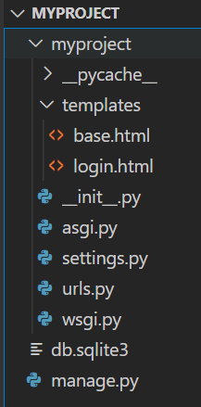

templates/ base.html :-

<html lang="en">
<head>
<title>{% block title %}{% endblock %}</title>
<!-- CSS only -->
<link rel="stylesheet" href="https://stackpath.bootstrapcdn.com/bootstrap/4.5.0/css/bootstrap.min.css"
integrity="sha384-9aIt2nRpC12Uk9gS9baDl411NQApFmC26EwAOH8WgZl5MYYxFfc+NcPb1dKGj7Sk" crossorigin="anonymous">
<!-- JS, Popper.js, and jQuery -->
<script src="https://code.jquery.com/jquery-3.5.1.slim.min.js"
integrity="sha384-DfXdz2htPH0lsSSs5nCTpuj/zy4C+OGpamoFVy38MVBnE+IbbVYUew+OrCXaRkfj"
crossorigin="anonymous"></script>
<script src="https://cdn.jsdelivr.net/npm/popper.js@1.16.0/dist/umd/popper.min.js"
integrity="sha384-Q6E9RHvbIyZFJoft+2mJbHaEWldlvI9IOYy5n3zV9zzTtmI3UksdQRVvoxMfooAo"
crossorigin="anonymous"></script>
<script src="https://stackpath.bootstrapcdn.com/bootstrap/4.5.0/js/bootstrap.min.js"
integrity="sha384-OgVRvuATP1z7JjHLkuOU7Xw704+h835Lr+6QL9UvYjZE3Ipu6Tp75j7Bh/kR0JKI"
crossorigin="anonymous"></script>
</head>
<body>
{% block content %}
{% endblock %}
</body>
</html>

template/login.html :-

{% extends 'base.html' %}
{% block title %} Login {% endblock %}
{% block content %}
<div class="container">
<div class="card mt-5" style="width: 15rem;">
<div class="card-header">Login</div>
<div class="card-body">
<form class="form" role="form" method="POST">
{% csrf_token %}
{{ form.as_p }}
<button type="submit" class="btn btn-primary">Login</button>
</form>
</div>
</div>
</div>
</div>
{% endblock %}

Step 3: Setup settings.py
Add template folder in TEMPLATES parameter in myproject/settings.py
'DIRS': [os.path.join(BASE_DIR, 'myproject', 'templates')],
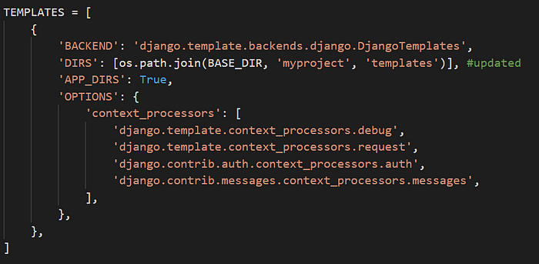
Add parameter LOGIN_REDIRECT_URL in myproject/settings.py
LOGIN_REDIRECT_URL = '/admin'

Step 4: Update urls.py
from django.contrib import admin
from django.urls import path
from django.contrib.auth import views as auth_views #new
urlpatterns = [
path('admin/login/', auth_views.LoginView.as_view(template_name='login.html'), name='login'), #new
path('admin/', admin.site.urls),
]

Step 5: Run server
Run server: python manage.py runserver

